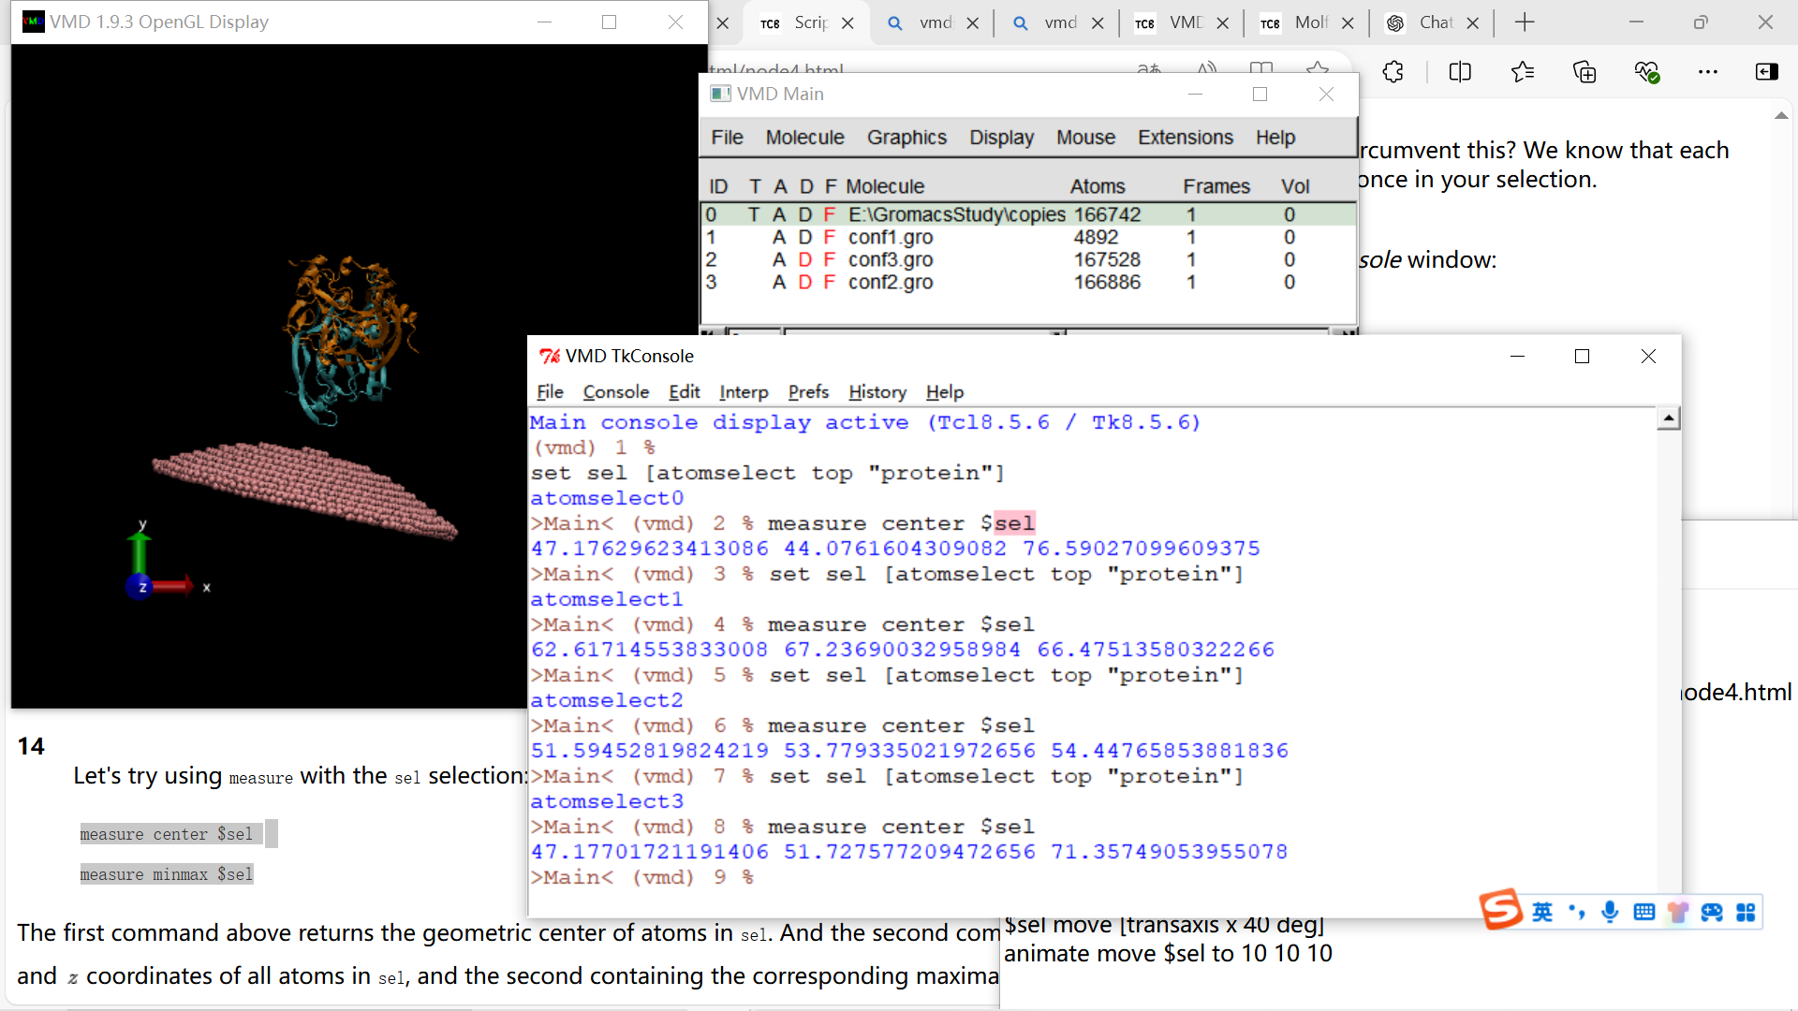Main console display active (Tcl8.5.6 / Tk8.5.6)

(vmd) 1 %

set sel [atomselect top "protein"]

atomselect0

>Main< (vmd) 2 % measure center $sel

47.17629623413086 44.0761604309082 76.59027099609375

>Main< (vmd) 3 % set sel [atomselect top "protein"]

atomselect1

>Main< (vmd) 4 % measure center $sel

62.61714553833008 67.23690032958984 66.47513580322266

>Main< (vmd) 5 % set sel [atomselect top "protein"]

atomselect2

>Main< (vmd) 6 % measure center $sel

51.59452819824219 53.779335021972656 54.44765853881836

>Main< (vmd) 7 % set sel [atomselect top "protein"]

atomselect3

>Main< (vmd) 8 % measure center $sel

47.17701721191406 51.727577209472656 71.35749053955078

>Main< (vmd) 9 %

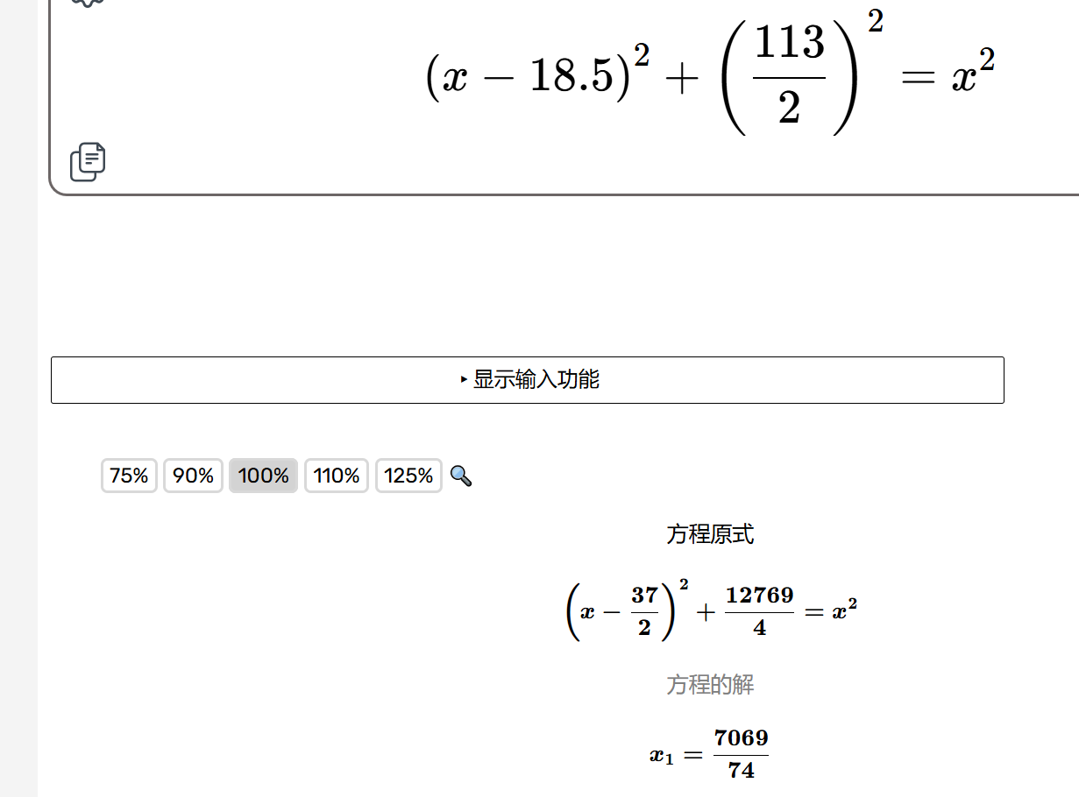

<https://mathdf.com/equ/cn/#expr=(x-18.5)%5E2%2B(113%2F2)%5E2%3Dx%5E2&arg=x>

推测AuNPs半径为1nm

